| https://lh3.googleusercontent.com/KfQQNVvbBoiwdGDQLnBv7fuYYOlIxmuNse6hxIp7yQH90FSw16KwWHyrwZjY1ERazE6j7ybJf1jU8x26Bg2XwycW7XqPP6-m61iqVirs8NkfSflSnzznpXbPjI4ZCaZ9JN3mOMxEr6M6mZ8zEA | **SOMAIYA**  **V I D Y A V I H A R**    **K J Somaiya Institute of Technology**  **An Autonomous Institute Permanently Affiliated to the University of Mumbai** |
| --- | --- |

**DEPARTMENT OF INFORMATION TECHNOLOGY**

**Course Name and Code:** Data Structures Lab **(**ITL302)

**Semester:** III (SYIT)

**Academic Year:** 2024-25 (Odd Semester)

**Experiment No. 03**

**Aim:** Implementations of Infix to Postfix Expression for real-world application

**Code with output :**

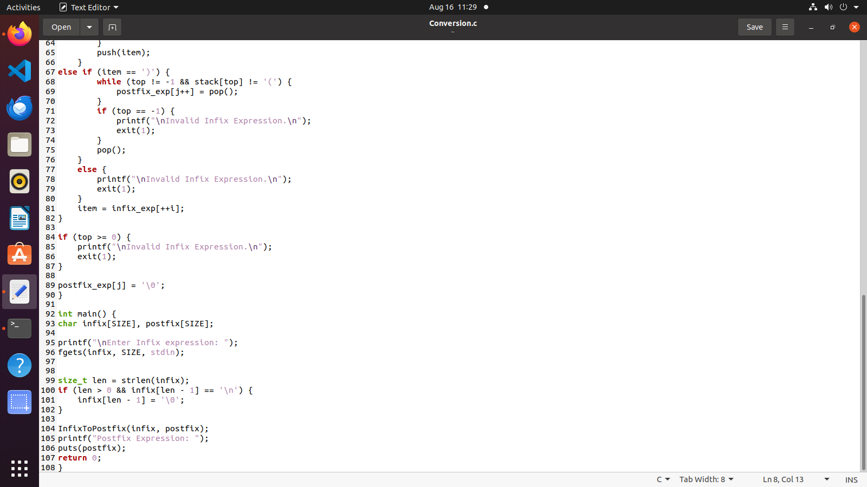

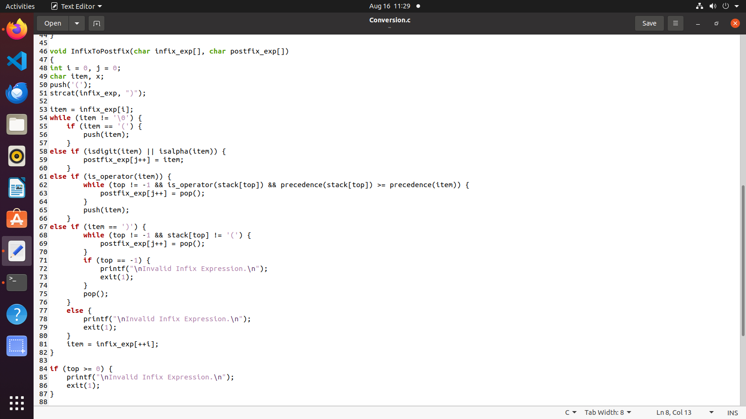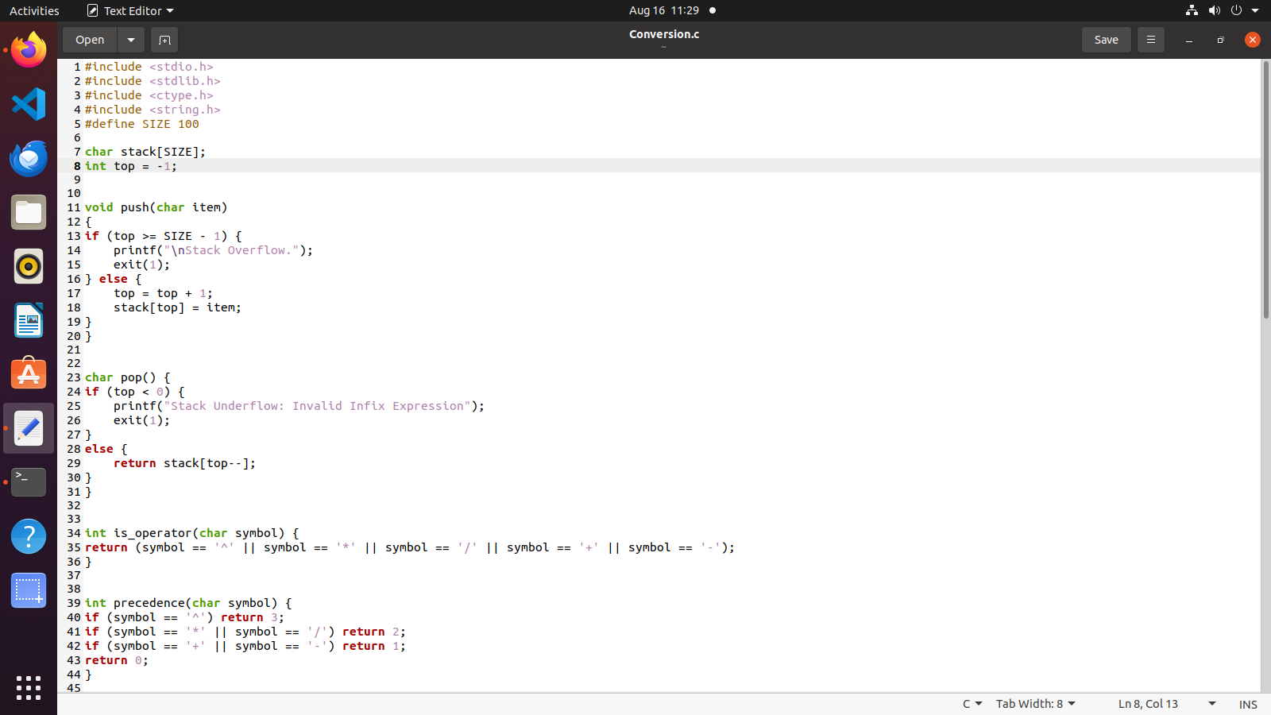

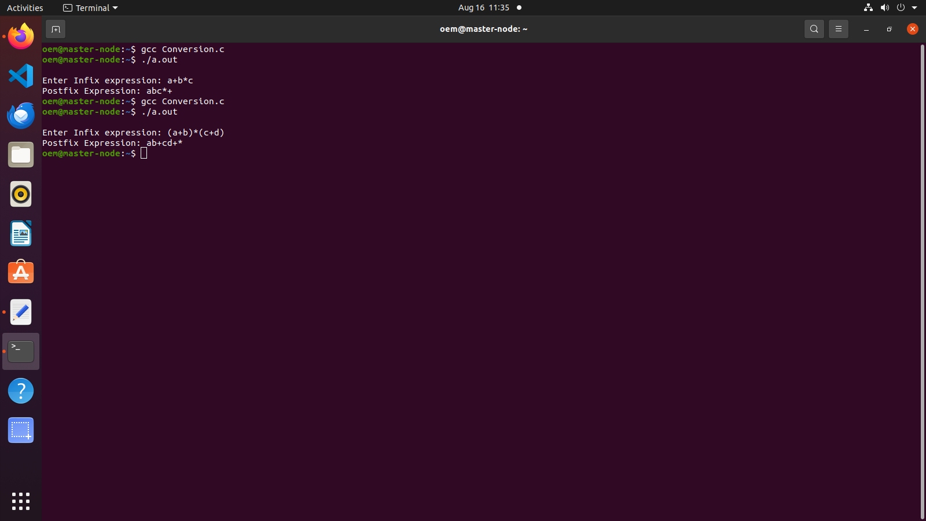

**Submitter Details:-**

**Name:** Abhinav.S.Dasari

**Roll No:** 16

**Div/Batch :** A/ S-2

**Date Of Performance:-** 16/8/2024

**Date Of Submission:-** 16/8/2024